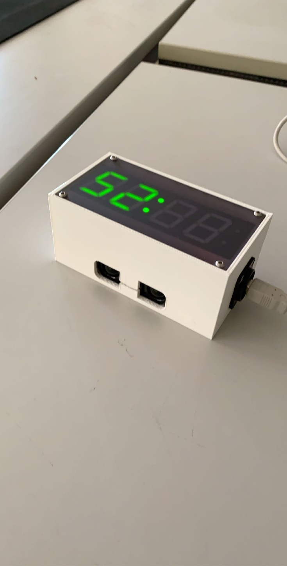Stopwatch with a distance sensor

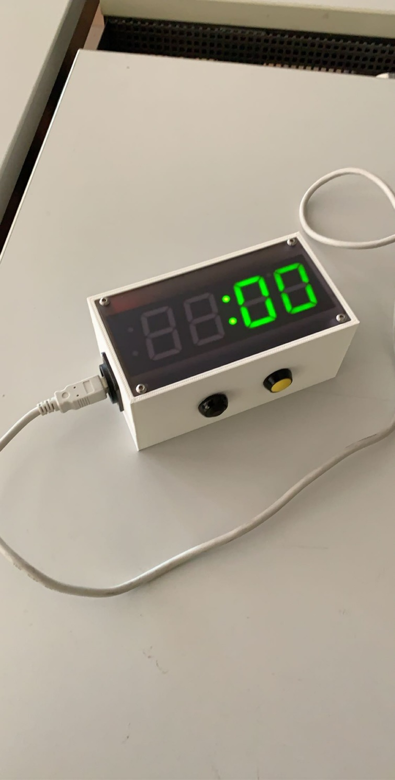

After the stopwatch stopped it has a 2 second pause, that you can read the time without accidently reset the time. After the 2 second it reacts to a trigger through a button the yellow button, distance sensor or through UART.

T the distance sensor works properly in a range of 1cm to 1.5m. Everything above (up to 3m) may not react every time.  
  
If the time counts over 99:99, it will show “OF” for overflow, but it is still counting (up to 655s 350ms).  
You can only read it out of the UART. Afterwards it will be reset to 0 and the time is lost.

The timer has a difference to the real time clock of 600ms after 10 minutes.

Buttons:

If the black switch is on, the stopwatch can only be triggered (start and stop) by the yellow button.  
Else the distance sensor triggers the stopwatch, the yellow button can be used too.

UART:

Settings:

115200 Baud, 8N1

If the device is starting a “Begin” comes. You can see it visually when it shows ": 00"

If the yellow button or the distance sensor triggers, it will be followed by the same answers as you would write the command (only 'S' and 'E’);

Send a char for a command:

TX: S

RX: START

TX: H

RX: ------------

RX: HELP

RX: ------------

RX: 'S' - START

RX: 'E' - END

RX: 'R' - RESET

RX: 'T' - TIME

RX: 'H' - HELP

------------

'S' -> For Start the stopwatch

Starts the stopwatch and sends a “START” back;

'H' -> For help

It shows all the available commands.

TX: R

RX: RESET

TX: E

RX: END

RX:

RX: Time:

RX: 42.87s

'R' -> For reset the timer

Resets the timer and  
waits at :00  
It sends a “RESET” back

'E' -> For stop the stopwatch

Stops the stopwatch and gives a “END” back, followed by “TIME” and the time measured in seconds

TX: T

RX: SHOW TIME ONRX: START

RX: 1

RX: 2

(…)

RX: 675

RX: 676

TX: T

RX: SHOW TIME OFF

'T' -> For show or hide the time

It sends the time that shows on the display.

The time is shown in n\*10ms.   
If you read a 675 it is 6s and 750ms